API SECURITY RISK ANALYSIS – PROJECT DOCUMENTATION
Prepared By
Satyasai Puppala
Internship
Future Interns – Cyber Security Internship

Introduction
This project focuses on performing an API Security Risk Analysis on a publicly available API using Postman. The objective is to identify potential security risks, analyze API responses, review authentication requirements, evaluate data exposure, and assess error handling mechanisms.
The API selected for this assessment is JSONPlaceholder, a free online REST API used for testing and learning purposes.
Target API:
https://jsonplaceholder.typicode.com/
Tool Used:
• Postman

Step 1: Environment Setup
- Download and install Postman from the official website.
- Launch Postman after installation.
- Create a new collection named:
API Security Assessment
- Save all requests inside this collection.
Purpose:
Postman allows testers to send HTTP requests and inspect API responses without requiring a browser.

Step 2: User Endpoint Analysis
Request:
GET https://jsonplaceholder.typicode.com/users
Procedure:
- Open Postman.
- Select GET request method.
- Enter the endpoint URL.
- Click Send.
Observation:
• Status Code: 200 OK
• User information is displayed.
• No authentication is required.
Evidence Collected:
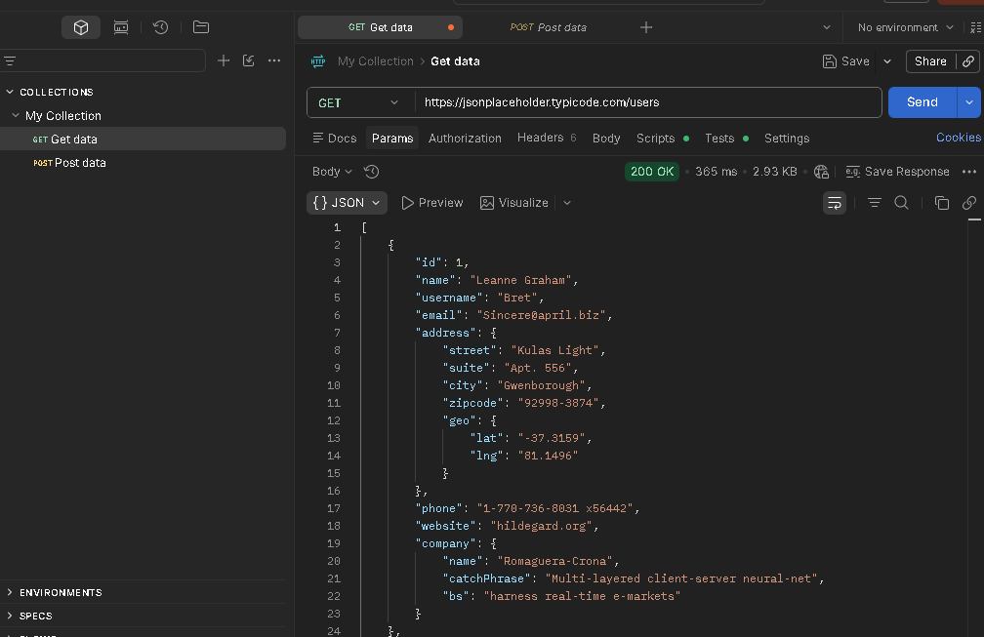
Security Observation:
The endpoint allows public access without requiring authentication.
Risk Level: Medium
Finding: No Authentication Required
Impact:
Unauthorized users may access exposed information if similar configurations are used in production environments.
Recommendation:
Implement authentication mechanisms such as API Keys, JWT Tokens, or OAuth.

Step 3: Posts Endpoint Analysis
Request:
GET https://jsonplaceholder.typicode.com/posts
Procedure:
- Create a new request tab.
- Enter the endpoint URL.
- Click Send.
Observation:
• Status Code: 200 OK
• Public posts are displayed.
• Data is accessible without login.

Evidence Collected:
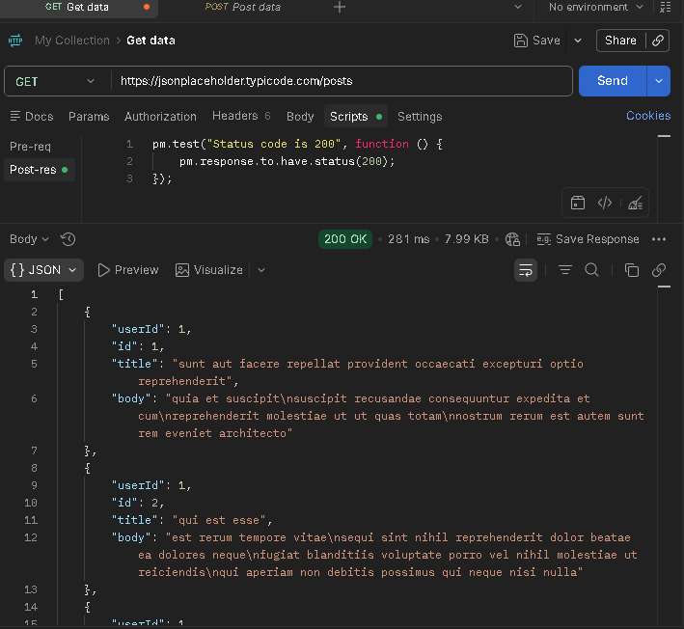
Security Observation:
Data is publicly accessible.
Risk Level: Low
Finding: Public Data Exposure
Impact:
Sensitive information may be exposed if production data is stored within publicly accessible endpoints.
Recommendation:
Limit returned fields and apply access control policies.

Step 4: Invalid Endpoint Testing
Request:
GET https://jsonplaceholder.typicode.com/admin
Procedure:
- Create a new request tab.
- Enter the invalid endpoint URL.
- Click Send.
Observation:
• Status Code: 404 Not Found
• API correctly rejects invalid requests.
Evidence Collected: 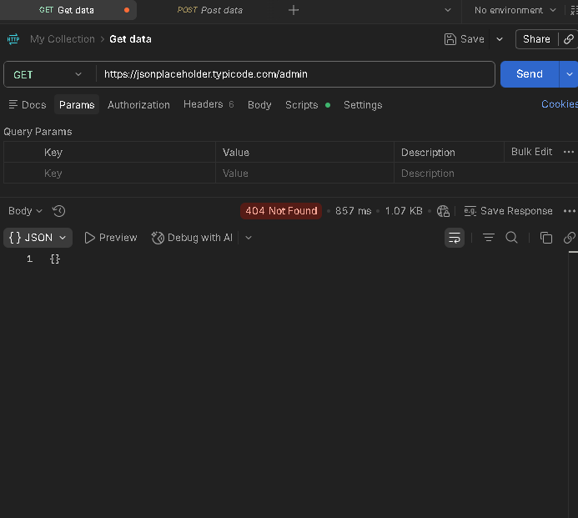

Security Observation: Proper error handling was implemented.
Risk Level: Informational
Finding: Proper Error Handling
Impact: No security issue identified.
Recommendation:
Continue using standardized error responses and secure error handling mechanisms.

Security Findings Summary
Finding 1
Title: No Authentication Required
Severity: Medium
Description:
The API allows unrestricted access to user information without requiring authentication.
Recommendation:
Implement JWT, OAuth, or API Keys.

Finding 2
Title: Public Data Exposure
Severity: Low
Description: Public endpoints expose information without access restrictions.
Recommendation:
Limit unnecessary data exposure and implement authorization controls.

Finding 3
Title: Proper Error Handling
Severity: Informational
Description:
The API returns appropriate HTTP status codes when invalid resources are requested.
Recommendation:
Maintain secure error handling practices.

Risk Assessment Table
Finding | Severity
No Authentication Required | Medium
Public Data Exposure | Low
Proper Error Handling | Informational

Conclusion
The API Security Risk Analysis successfully identified several important security observations. The assessment revealed that the API provides unrestricted access to resources and exposes publicly accessible data. While this behavior is acceptable for a demonstration API, production APIs should implement proper authentication and authorization controls.
The assessment also confirmed that the API implements proper error handling by returning appropriate HTTP status codes for invalid requests.
This project provided practical experience in API testing, endpoint analysis, risk identification, security documentation, and professional reporting. These skills are essential for cybersecurity professionals involved in API security assessments and vulnerability management.

